Introduction
This document is the IHE Framework Configuration User Interface Specification (Phase 2). The document describes the way in which the configuration UI should work after an evaluation of the configuration UI developed in Phase 1.

Configuration
The configuration is build up in steps. The idea is to connect Actors together to form Devices and the connect the Devices together to form a Network.

Step 1 – Blank work area
Starting up the configuration UI for the first time (or when a new configuration is to be made) would display the UI as in Figure 1.
The supported actors are available from the Toolbox on the left hand side of the UI.
The list of supported actors is created by reading in actor description files from a fixed directory. The number of description files present in the directory defines the number of supported actors.

NOTE 1: The extension on the actor name (“_ID1”) is the actor id and should not be present in the actor name for Phase 2.

NOTE 2: The work area is effectively the container for Actors and Devices configured. This was termed a Network in Phase 1 – note sure what to call it in Phase 2 – the underlying IHE Framework groups actors into Integration Profiles – so the Integration Profile is the container used in the IHE Framework. We will use Work Area for the time being.

Figure 1: Blank work area
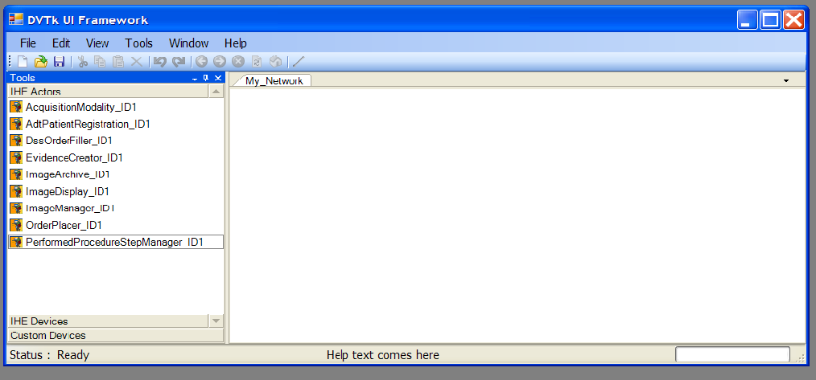

At this step it should be possible to do the following:

- Edit the name of the Work Area – shown as “My_Network” in Figure 1.
- Save the Work Area to an XML file – from File menu -> Save / Save As.
- Load a Work Area from an XML file – from File menu -> Open.
- Create a new Work Area – from File menu -> New.

Step 2 – Actor dragged onto work area
The Work Area is used to contain the actors and devices.
An actor can be dragged from the actor Toolbox onto the Work Area as in Figure 2.

Figure 2: Actor dragged onto work area
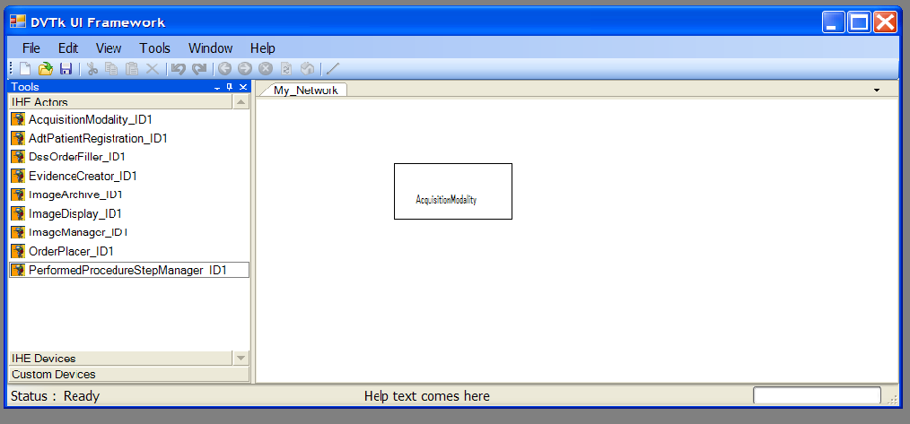

At this step it should be possible to do the following:

- Drag an actor from the Toolbox onto the Work Area – left mouse-click (hold-down) on actor in Toolbox and drag to Work Area.
- Move an actor around the Work Area – left mouse-click (hold-down) on actor in Work Area and drag around Work Area.
- Display context specific menu above actor – right mouse-click on top of actor. The context specific menu should have (initially) the following options:
  - Properties – select this option to display the actor specific properties – example Actor Name (fixed), Id, Default AE Title, IP address, etc. The list of properties should be very easy to extend from within the UI Framework code.
  - Delete – select this option to delete the actor from the Work Area – all references to the actor in the work area should be removed.
The number of menu options should be very easy to extend from within the UI Framework code.
- Drag an actor from the toolbox of the same type as already in the Work Area (new instance of the actor). In this case the Actor Id (one of actor properties) should automatically be incremented for this instance so that it can be identified uniquely.
- Edit the name of the Work Area – shown as “My_Network” in Figure 2.
- Save the Work Area to an XML file – from File menu -> Save / Save As. The actors in the Work Area should be saved allowing the Work Area to be redrawn if the XML file is re-loaded.
- Load a Work Area from an XML file – from File menu -> Open. The Work Area including the location of configured actors should be re-drawn from the contents of the XML file.
- Create a new Work Area – from File menu -> New.

Step 3 – Actors connected together
Actors can be connected together to allow messages to be passed from one actor to another. A connection can be unidirectional or bidirectional.
Assume that two actors have been dragged from the Toolbox onto the Work Area as in Figure 3.

Figure 3: Actors connected together
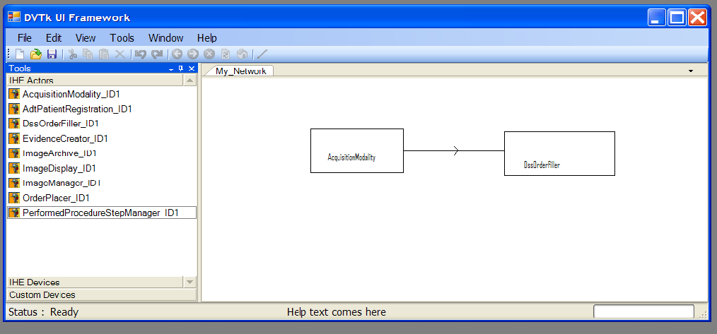

At this step it should be possible to do the following:

- Connect the actors – double left mouse-click on the actor that initiates the message flow. Move to the second actor and a single left mouse-click on the actor. The connection line should be drawn between the two actors with an arrow in the middle indicating the direction. The connection should avoid other (not connected) actors that are in the Work Area.
- Move one of the connected actors around the Work Area – left mouse-click (hold-down) on actor in Work Area and drag around Work Area. The connection line should “move with” the actor.
- Display context specific menu above the connection line - right mouse-click on top of connection line. The context specific menu should have (initially) the following options:
  - Properties – select this option to display the connection specific properties – example Protocol Type (DICOM, HL7), Direction (bi-directional connection would be chosen here), TCP/IP Port Number, etc. The list of properties should be very easy to extend from within the UI Framework code.
  - Delete – select this option to delete the connection line from the Work Area – all references to the connection line in the work area should be removed.
The number of menu options should be very easy to extend from within the UI Framework code.
- Edit the name of the Work Area – shown as “My_Network” in Figure 3.
- Save the Work Area to an XML file – from File menu -> Save / Save As. The actors and connection lines in the Work Area should be saved allowing the Work Area to be redrawn if the XML file is re-loaded.
- Load a Work Area from an XML file – from File menu -> Open. The Work Area including the location of configured actors and connection lines should be re-drawn from the contents of the XML file.
- Create a new Work Area – from File menu -> New.

Step 4 – Selecting Actors to form a Device
Actors can be grouped together to form Devices as in Figure 4. A Device is normally manufacturer specific.

Figure 4: Selecting Actors to form a Device
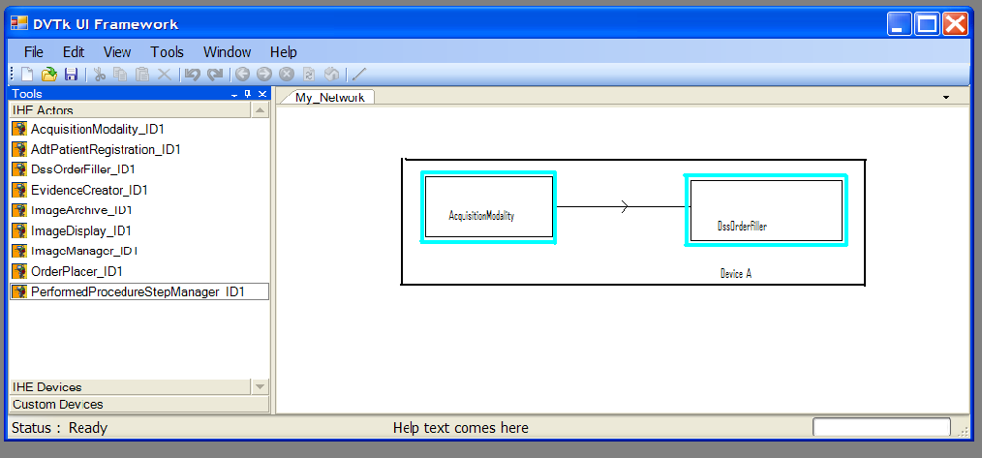

At this step it should be possible to do the following:

- Select the Actors that should be grouped together to form the device. Hold down the SHIFT key and left mouse-click on each actor that should be grouped – the selected actors should be high-lighted. Once all the required actors have been selected release the SHIFT key. A block containing all the actors should be drawn around them and a default name of “Device A” assigned to the block.
- Move the Device (including contained Actors and connection lines) around the Work Area - left mouse-click (hold-down) inside the device boundary block (but not on an actor or connection line) and drag around Work Area.
- Drag the Device into the Toolbox - left mouse-click (hold-down) inside the device boundary block (but not on an actor or connection line) and drag to Custom Devices section of the Toolbox. An entry with the Device Name should be created and the Device description stored in an XML file in the custom device directory.
- Display context specific menu above the Device - right mouse-click inside the device boundary block (but not on an actor or connection line). The context specific menu should have (initially) the following options:
  - Properties – select this option to display the Device specific properties – example Manufacturer, Device Name, Version Number, Default AE Title, Default IP Address, etc. The list of properties should be very easy to extend from within the UI Framework code.
  - Delete – select this option to delete the Device from the Work Area – all references to the Device in the work area should be removed. A message box asking if the contained Actors should be deleted too should be shown.
The number of menu options should be very easy to extend from within the UI Framework code.
- Edit the name of the Work Area – shown as “My_Network” in Figure 4.
- Save the Work Area to an XML file – from File menu -> Save / Save As. The devices, actors and connection lines in the Work Area should be saved allowing the Work Area to be redrawn if the XML file is re-loaded.
- Load a Work Area from an XML file – from File menu -> Open. The Work Area including the location of configured device, actors and connection lines should be re-drawn from the contents of the XML file.
- Create a new Work Area – from File menu -> New.

Step 5 – Connecting Devices
This step involves connecting different devices together. These Devices can be predefined groups of Actors that constitute the IHE Devices or Custom Devices created as in step 4.
The devices are connected as in Figure 5.

Figure 5: Connecting Devices
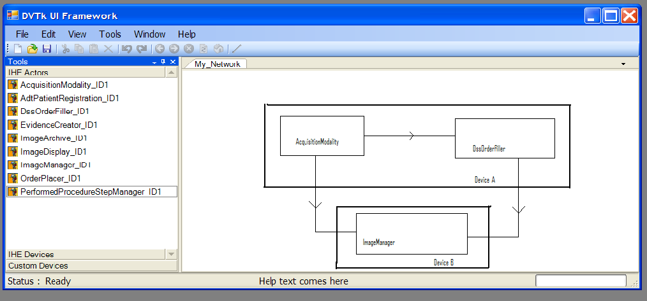

At this step it should be possible to do the following:

- Drag other devices onto the Work Area from either the IHE Devices or Custom Devices Toolbox - – left mouse-click (hold-down) on device in Toolbox and drag to Work Area.
- Connect two devices together by connecting the appropriate actor within one device with the corresponding actor in the second device - double left mouse-click on the device/actor that initiates the message flow. Move to the second device/actor and a single left mouse-click on the actor. The connection line should be drawn between the two actors with an arrow in the middle indicating the direction. The connection should avoid other (not connected) actors that are in the Work Area.
- Move one of the connected devices around the Work Area – left mouse-click (hold-down) inside the device boundary block (but not on an actor or connection line) in Work Area and drag around Work Area. The contained actors and connection lines should “move with” the device.
- Display context specific menu above the connection line between two devices - right mouse-click on top of connection line. The context specific menu should have (initially) the following options:
  - Properties – select this option to display the connection specific properties – example Protocol Type (DICOM, HL7), Direction (bi-directional connection would be chosen here), TCP/IP Port Number, etc. The list of properties should be very easy to extend from within the UI Framework code.
  - Delete – select this option to delete the connection line from the Work Area – all references to the connection line in the work area should be removed.
The number of menu options should be very easy to extend from within the UI Framework code.
- Indicate that a device is a System Under Test (SUT) so not emulated by DVTk – this could be indicated by the type of border around the device for example – so it should be possible to defined the line type for the border.
- Edit the name of the Work Area – shown as “My_Network” in Figure 5.
- Save the Work Area to an XML file – from File menu -> Save / Save As. The devices, actors and connection lines in the Work Area should be saved allowing the Work Area to be redrawn if the XML file is re-loaded.
- Load a Work Area from an XML file – from File menu -> Open. The Work Area including the location of configured devices, actors and connection lines should be re-drawn from the contents of the XML file.
- Create a new Work Area – from File menu -> New.

UI Design Considerations
The following design considerations should be taken into account when developing the UI:

- Use of drag and drop.
- Use of selectable display areas – click within a block or a line.
- Use of context specific menus – easy expanded from within the UI Framework with additional options.
- XML serialisation of Work Area for saving and reloading.
- Easy access to drawn primitives from within the IHE Framework – in future it will be necessary to be able to control the colour of a connection line for example from within the IHE Framework so that message flows can be displayed – so that this same UI framework can be used at runtime (so not only for configuration).
- Extension with new actors / devices – this detail should be read from the actor / device description files – no hard coded knowledge as is the case in Phase 1.

